Space Explorers

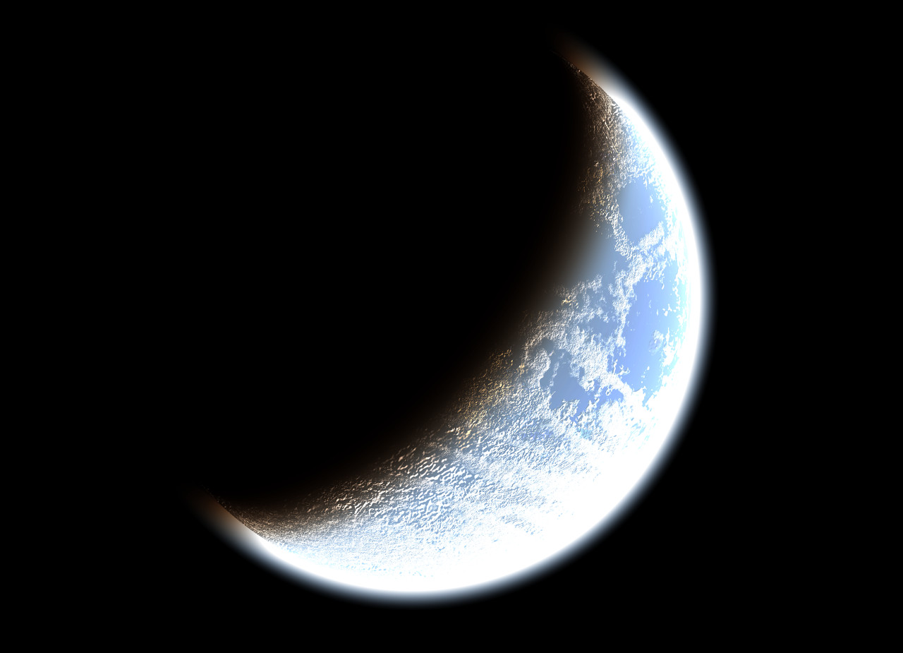
Group 1 – Mercury
Kate, Jenna, & Molly

Group 2 – Venus
John, Ben, & Mark

Group 3 – Earth
Jackie, Nina, & Paula

Group 4 – Mars
Joey, Patrick, & Noah

Group 5 – Jupiter
Sarah, Abby, & Christina
Group 6 - Saturn
Adam, Kenny, & Justin

Group 7 – Uranus
Rebecca, Tiffany, & Faith

Group 8 – Neptune
Leo, Quinn, & Chris

Group 9 – Pluto
Isabella, Olivia, & Paige

Images Courtesy of: Microsoft Clip Art

